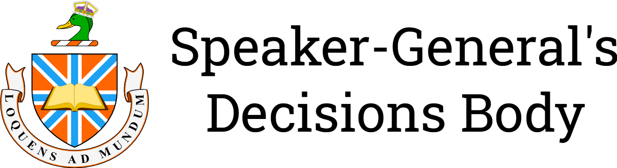
Re Singing of National Anthems [2024] SpkGenDec 7
Decision of: | The Speaker-General
Date of decision: | 1 September 2024
Catchwords: | Music—Singing—National anthems—Singing of national anthems at events.
Number of paragraphs: | 9

DECISION
DECISION MADE BY: THE SPEAKER-GENERAL
DATE OF DECISION: 1 SEPTEMBER 2024
THE DECISIONS BODY DECIDES THAT:
- National anthems should never be be sung by fewer than four people.

REASONS FOR DECISION
THE SPEAKER-GENERAL
- National anthems (anthems) are songs that represent a whole country. Most anthems contain lyrics that are sung. Anthems are performed at official occasions such as coronations, inaugurations, funerals, remembrance events, sporting events and the like. At such events, organisers will generally choose a person or group to sing the anthem and to have either have a band perform the anthem or play a pre-recorded instrumental. I will put forth in these reasons, why anthems should never be sung with a group of fewer than four people.
- The main anthem that I will use for these reasons is "The Star-Spangled Banner" (US anthem), the anthem of the United States of America, for the simple reason that there are a lot of different examples from different events, from the inauguration of the President of the United States to grass-roots baseball games. The decision applies to all anthems and similar types of songs.
- Whitney Houston’s performance that preceded Super Bowl XXV is one example of a single performer singing the US anthem. Some syllables are held for too long, such as during “what so prooooudllllly we hail”; “last gleaming” and “Whose broad stripes and bright stars” sounded a bit awkward; “perilous light” was held for too long. The lyrics in Houston’s rendition just feels slow. Some slow renditions of songs can sound good but not in this case. “[G]allantly streaming” was sing like Houston had run out of breath.
- The problem with a single talented performer singing an anthem, particularly the US anthem with its combination of high notes and low notes is that performers use their talent to achieve such notes, making it very difficult for most people who do not have such talent follow along. This effectively gatekeeps the singing of anthems which should be easy for anyone to sing along with.
- Groups of four or more people who sing will alleviate the problem by firstly having performers with different vocal ranges; this solves the problem ordinary people following along to a single singer by having people follow the voice that suits their range the best.
- Secondly by having multiple people, there is less pressure on the performers on getting the pitch of notes correct. The other performers can cover for such mistakes.
- Finally, having a group of people singing as richness to the anthem. One of the problems with having a single performer singing is that, at times, the anthem will fell like it is missing something. Like a song with no bass later. Even three performers might fail to fill the gap. This is why I recommend having four performers as a minimum. Also, because how many barbershop trios have you seen? If you have seen some than they are incomplete as barbershop quartets have four for a reason, the lead, a bass, a tenor, and a baritone (Wikipedia contributors, 2024). Have four members also makes it possible to form a square, adding to the visual impact of the performance.
- I will not recommend an upper limit as the more performers the better, as many performers as can fit on the stage. If the audience joins in, even better. A performance of the “State Anthem of the Union of Soviet Socialist Republics” in 1977 during the All-Union Festival of Amateur Workers’ Creativity had—by my count—roughly 200–300 performers on stage singing in addition to the audience (Музыка на советском телевидении, 1977/2023).
- For the reasons stated above, I decide that national anthems should never be be sung by fewer than four people.
I certify that the preceding nine (9) numbered paragraphs are a true copy of the reasons for decision of the Honourable the Speaker-General.
Signature:
Date: 1 September 2024

References
Музыка на советском телевидении. (2023). Гимн СССР. Всесоюзный фестиваль самодеятельного творчества трудящихся (1977) [Anthem of the USSR. All-Union Festival of Amateur Workers’ Creativity (1977)] [Video]. YouTube. youtu.be/S4NhT0TyHVY
Wikipedia contributors. (2024, August 27). Barbershop quartet. In Wikipedia. Retrieved 13:47, 28 August 2024, from https://en.wikipedia.org/w/index.php?title=Barbershop_quartet&oldid=1242561722

